**CHAPTER 1**

**Speech Activity**

There are many heroes in our society and one of them is “ABDUL SATTAR EDHI”. His truthfulness, honesty and morality has provided a basic platform for his integrity and respect. And that make him one of the World’s 500 Most Influential Muslims personality, having biggest welfare organization in Pakistan with 1800+ ambulances 28 rescue boats, providing facilities to humanity. We can relate his honesty and determination for the people from this incident that two Edhi drivers who had been fired by in front of him, for eating with the poor. **He said “You are paid a salary”, “you should eat from that money, and this food is not meant for you”.**

Another event that make his personality great and respectful that throughout his life, He helped people he didn't even know, by begging for money personally on their behalf. Throughout the year, He was often seen caring for orphans. He showed the love within his work, not only by sacrificing his personal time, but also donating his necessities. His famous quote is **“When you stop living for luxuries, you understand the real meaning of life”.** And that is the reason that he had awarded highest civil military award “Nishan-e-Imtiaz” of Pakistan in 1989 and from his efforts and contribution to the society he is known as “Angel of Mercy”.

**Assessment Activity**

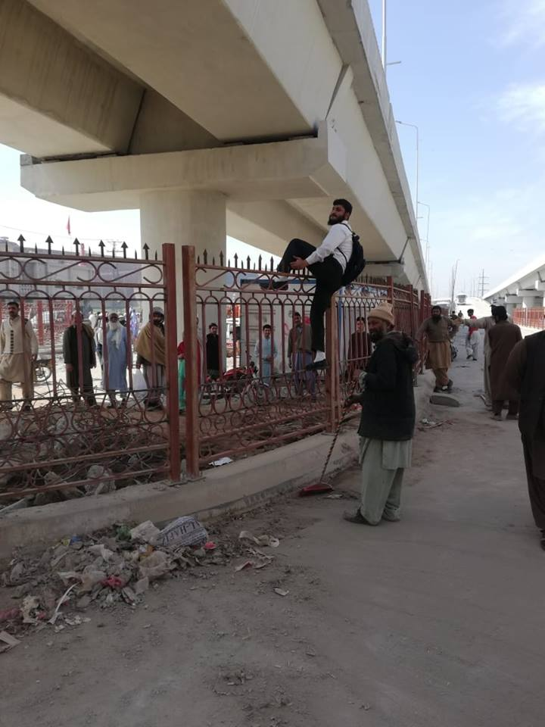In this picture a man is crossing road by climbing on a barrier which purpose is to prevent people to cross ,but this man is violating rules of rules of responsibility and respect as citizen.

**Communicating Over the Internet**

|  |  |
| --- | --- |
| **ADVANTAGES** | **DISADVANTAGES** |
| Entertainment. | Time Consuming |
| Easy to use. | Fake News |
| Comfortable | Addiction |
| Connection even through long distance | Misunderstanding |
| Affordable | Health issues |
| Easy for introvert | Lack of Body language |
| **I**nformative | Cyber Crime |

**Analysis**

Internet has definitely made our lives better and it has impact on a society. But with wise use, as excessive use of everything is bad. If we use internet upto certain extent so we can take maximum benefit from it and can avoid many of its disadvantages.